**-- 📊 Advanced SQL: CTEs & Window Functions – Urban Noise Analytics**

**-- Query 1: CTE – Avg Noise Per Sensor Per Area**

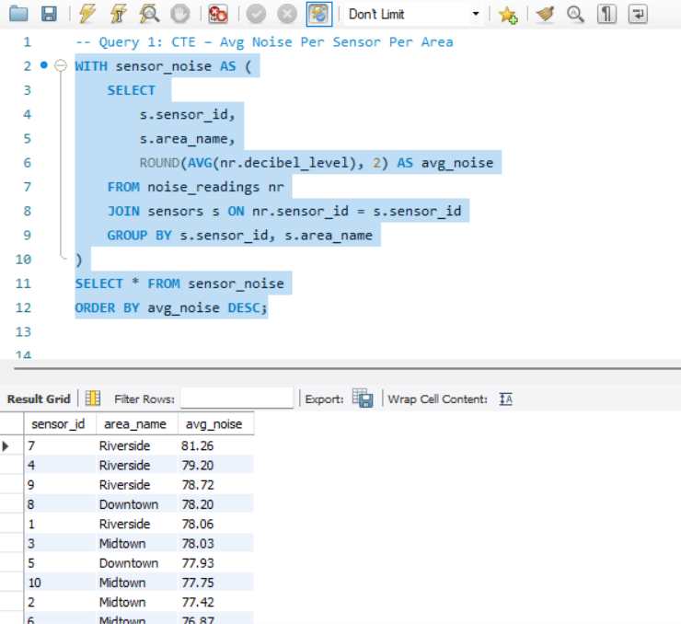

**-- Query 2: RANK – Loudest Days Per Area**

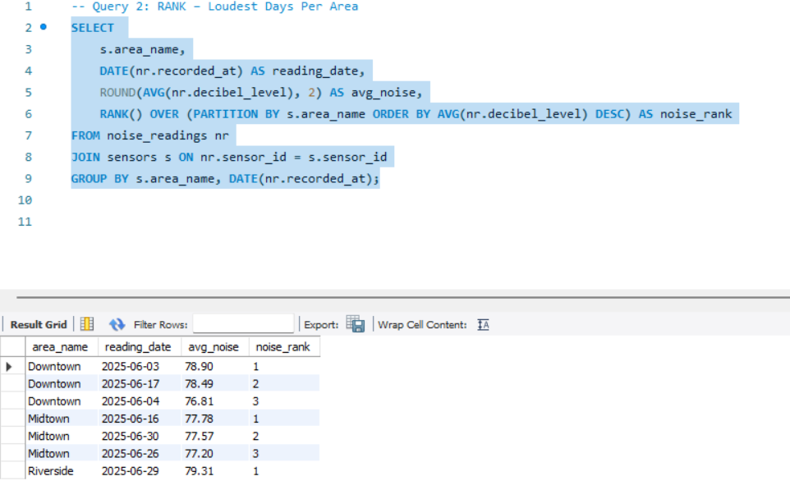

**-- Query 3: LAG – Compare Today vs Yesterday’s Avg Noise**

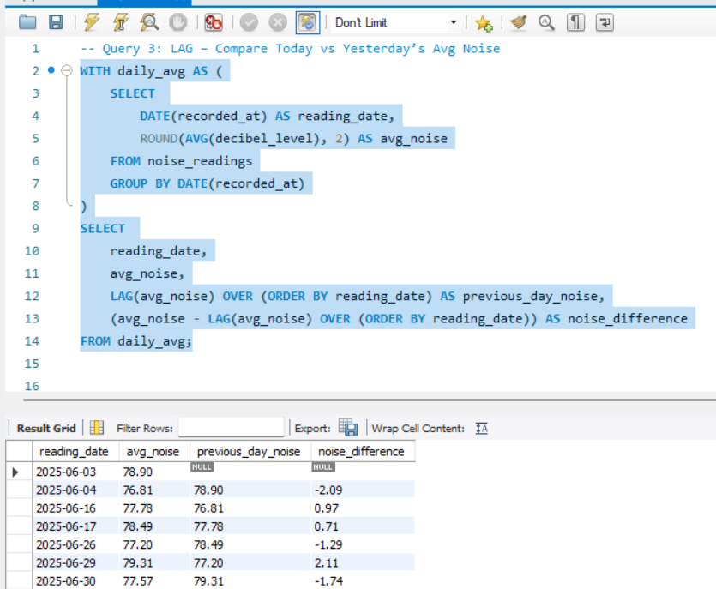

**-- Query 4: ROW_NUMBER – First Reading Per Sensor**

